Mass Spectrometry Tool for the Analysis of Fragment Ions (MS-TAFI) User Guide

11

120

130

140

10

9

8

7

6

5

4

3

1

2

1. Opens a window to upload a .csv file containing the deconvoluted mass/intensity data generated from Xtract

**Data format**. Exporting deconvoluted data from QualBrowser or Freestyle should automatically generate .csv file in this format.

1. Text box to paste protein sequence of interest.
2. Text box to enter PTM position(s). Can leave blank if no PTM’s are present.

**Example format:** 1,16,17

1. Text box to enter PTM mass(es): Can leave blank if no PTM’s are present.

**Example format:** 42.010565,-1.008, 615.17

1. Text box to enter ligand mass (if applicable)
2. Drop down menu to select activation method.

**Options:**

* **CID (b,y)**
* **HCD (b,y)**
* **ETD (c,z)**
* **EThcD (b,y,c,z)**
* **UVPD (a,a+1,b,c,x, x+1,y,y-1, y-2, z)**

1. Text box to enter desired PPM error for fragment search (10 ppm by default)
2. Text box to enter TIC if user wishes to normalize results. (1 by default if no normalization is desired)
3. Drop down menu allowing user to search for apo- or holo- ions (apo by default)
4. **GO Button to generate results**. **Must hit go before using any of the graphing capabilities**

* Hitting GO will generate the protein’s monoisotopic mass, the sequence coverage, sequence length, and % fragments explained. Two tables will also be generated which can be copy-pasted into excel if desired.
* The top table contains the ion type, position, raw fragment intensity, TIC adjusted intensity, observed mass, theoretical mass, ppm error, reference position, and N/C terminal classification.
  + Position refers to the position of an ion in relation to the termini which it contains. **This is the standard way that we refer to ions** (i.e. c6, z5, a3 etc.)
  + Reference position refers to the absolute position of an ion in relation to the N-terminus (this value is a way of standardizing ion position for graphing)
* The bottom table organizes the TIC adjusted intensity and ion type according to the reference position (for easy graphing in excel if desired)

1. Graphs TIC adjusted intensity according to all ion types in a web browser

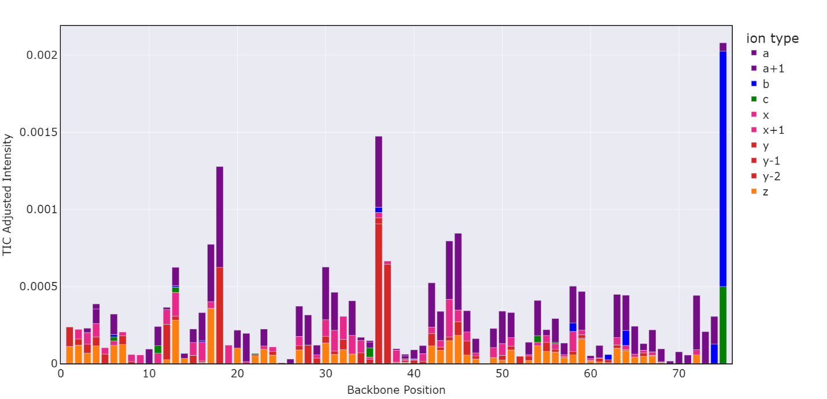

* Graphs have full interactivity. Users can hover over the different bars to see the ion type, intensity, and position information. Users can also zoom in on the graph and toggle the displayed ion types by clicking on the legend symbols in the upper right

1. Graphs TIC adjusted intensity according to N/C-terminal classification in a web browser. This essentially generates a simplified version of the graph shown above

1. Generates a sequence coverage map

1. Navigate to Charge Site Analysis feature (See next page for more information)

This feature requires UVPD data as the use of a, a+1 and x, x+1 ions are used to generate results

8

7

6

5

4

3

2

1

1. Opens a window to upload a .csv file containing the deconvoluted mass/intensity data generated from Xtract (more detail provided on page 2)
2. Table

   Description automatically generatedOpens a window to upload a .xls file containing the deconvoluted mass/charge information. **MUST USE FREESTYLE TO GENERATE.**

EXPORT THIS TABLE

* Deconvolute mass spectra using Freestyle
* Select table by clicking on it in the viewer
* Navigate to “Export” at the top of the screen, and select “Export selection as”

* A window will pop up asking you to select the export file type. Select “To CSV File”. Even though you are selecting a .csv file, it will export the table as a .xls file (this is correct)

* The exported table should look something like this:

1. Text box to paste protein sequence of interest.
2. Text box to enter PTM position(s). Can leave blank if no PTM’s are present.

**Example format:** 1,16,17

1. Text box to enter PTM mass(es): Can leave blank if no PTM’s are present.

**Example format:** 42.010565,-1.008, 615.17

1. Text box to enter desired PPM error for fragment search (10 ppm by default)
2. GO button to generate charge site analysis plots. Generates two plots: one using a, a+1 ions and another using x, x+1 ions

1. Navigate back to fragment intensity tool